**INDEX**

|  |  |  |
| --- | --- | --- |
| **Sr. No.** | **Topic** | **Page no.** |
| 1. | Introduction | 7 |
| 2. | Existing System | 8 |
| 3. | Scope of Work | 9 |
| 4. | Operating Environment   1. Hardware Requirement 2. Software Requirement | 10 |
| 5. | Design   1. DFD 2. ER Diagram 3. Data Dictionary | 11 |
| 6. | Input Screen | 13 |
| 7. | Sample Code | 16 |
| 8. | Future Enhancement | 25 |
| 9. | Limitations | 26 |
| 10. | Bibliography | 27 |

**Introduction**

An ecommerce website is a digital platform that allows businesses to sell their products or services online. This type of website has become increasingly popular over the past few years, thanks to the rise of online shopping and the convenience that it provides to consumers. With an ecommerce website, businesses can reach customers all over the world and offer them a seamless shopping experience, from browsing products to making a purchase and receiving delivery.

One of the most important components of an ecommerce website is the user experience. A well-designed and easy-to-navigate website will help to attract and retain customers, while a confusing or poorly designed website can drive them away. This includes everything from the layout and design of the website to the search and filtering features that allow customers to find the products they are looking for. A good ecommerce website should also offer a range of payment options and secure payment processing to ensure that customers can shop with confidence.

**Existing System**

There are many existing systems, each with its own unique features and functionality. However, most ecommerce websites share some common characteristics in terms of their system architecture and design. In this section, we will provide an overview of the typical system architecture and components of an ecommerce website.

User Interface: The user interface is the front-end component of the ecommerce website that is visible to the user. It includes the website design, layout, navigation, and user interaction elements such as buttons, forms, and search bars. The user interface should be designed to be visually appealing and easy to use, in order to provide a good user experience.

Product Catalog: The product catalog is a database that contains information about all the products that are available for sale on the website. This information typically includes the product name, description, price, images, and other relevant details. The product catalog is usually managed by an admin panel or content management system, which allows the website owner to add, edit, and delete products as needed.

**Scope of Work**

Scope of Project: -

The objective of this project is to design and develop an online bakery product selling website that allows customers to purchase bakery products online. The website will feature an intuitive and easy-to-use interface that allows users to browse products, add them to their shopping cart, and make purchases securely

Project Work: -

The project work timeline will be broken down into the following phases:

1. Planning and Requirements Gathering: 1 week
2. Website Design: 2 weeks
3. Website Development: 4 weeks
4. Testing: 1 week
5. Documentation and Deployment: 1 week

Total Project Duration: 9 weeks

**Operating Environment**

1. **Hardware Requirement**

|  |  |
| --- | --- |
| **Processor:** | Intel Core i3 / any updated |
| **Disc Space:** | 20GB |
| **RAM:** | 4GB |

1. **Software Requirement**

|  |  |
| --- | --- |
| **Operating System:** | Windows |
| **Development Tools:** | VS Code |
| **Development Language:** | HTML, CSS, JavaScript |

**Design**

1. **DFD: - Data Flow Diagram**

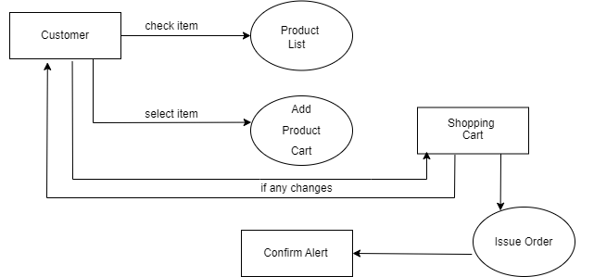

1. **ER Diagram: - Entity Relationship Diagram**

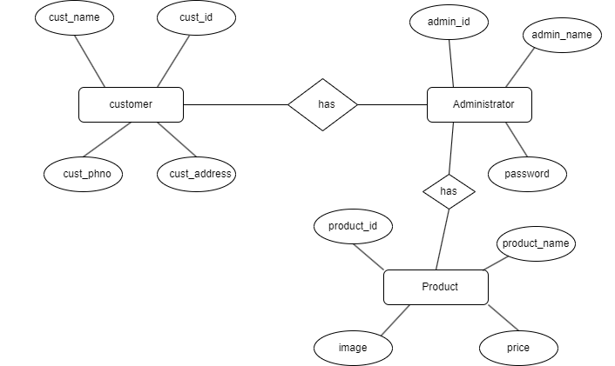

1. **Data Dictionary**

|  |  |  |  |  |
| --- | --- | --- | --- | --- |
| Field Name | Data type | Field Length | Constraint | Description |
| Customer_id | number | 5 | Primary Key | Auto generated |
| Cust_name | varchar | 15 | Not null | Name of a Customer |
| Cust_phno | number | 10 | Not null, Primary key | Mobile number |
| Cust_pass | varchar2 | 10 | Not null | Login Password |
| Product_id | number | 5 | Primary Key | Auto generated |
| Product_name | varchar | 20 | Not null | Name of Product |
| Product_price | number | 10 | Not null | Price of Product |

**Input Screen**

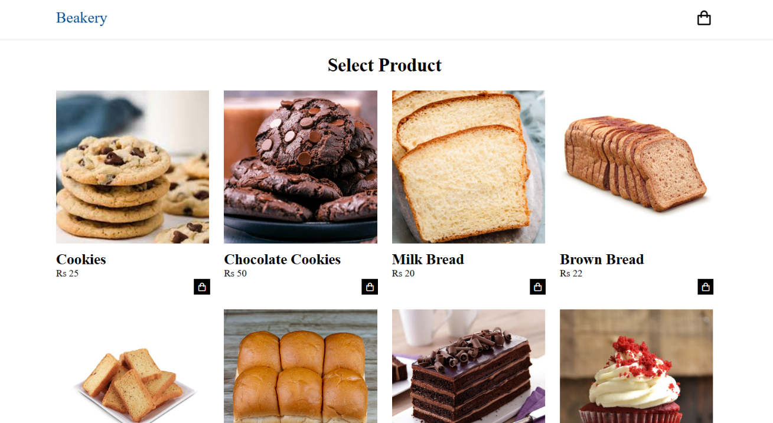

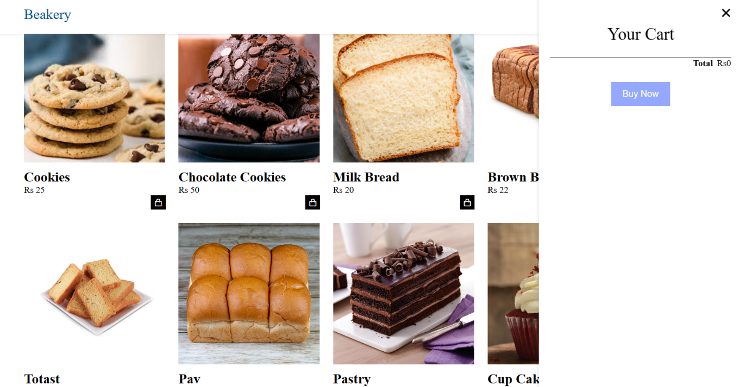

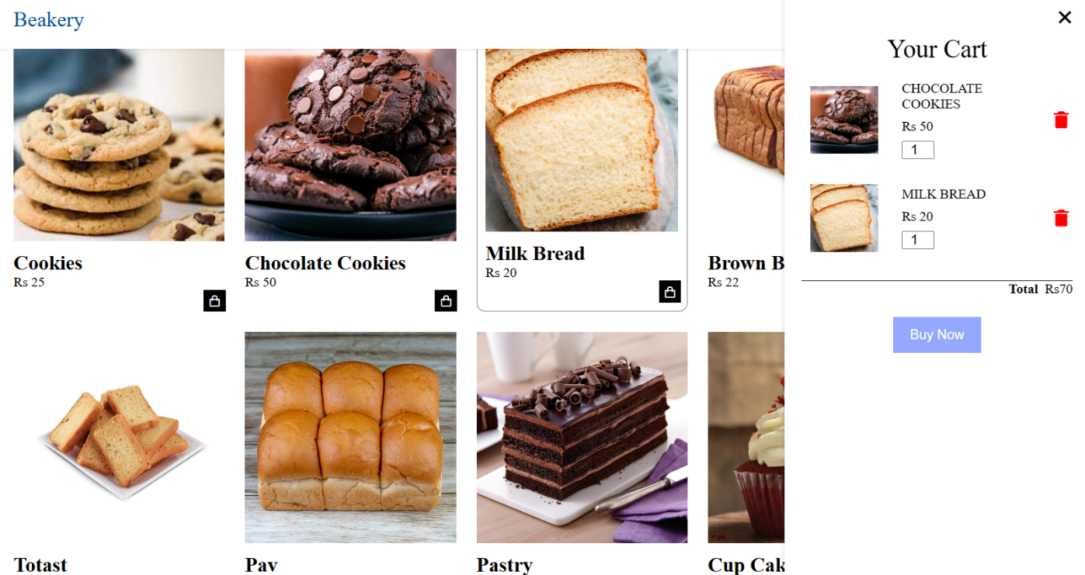

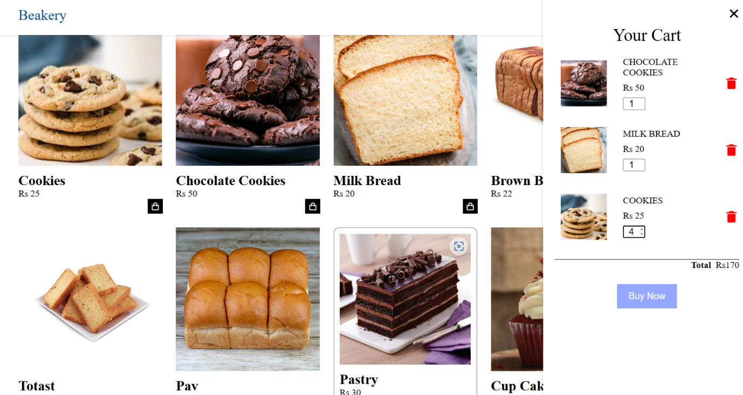

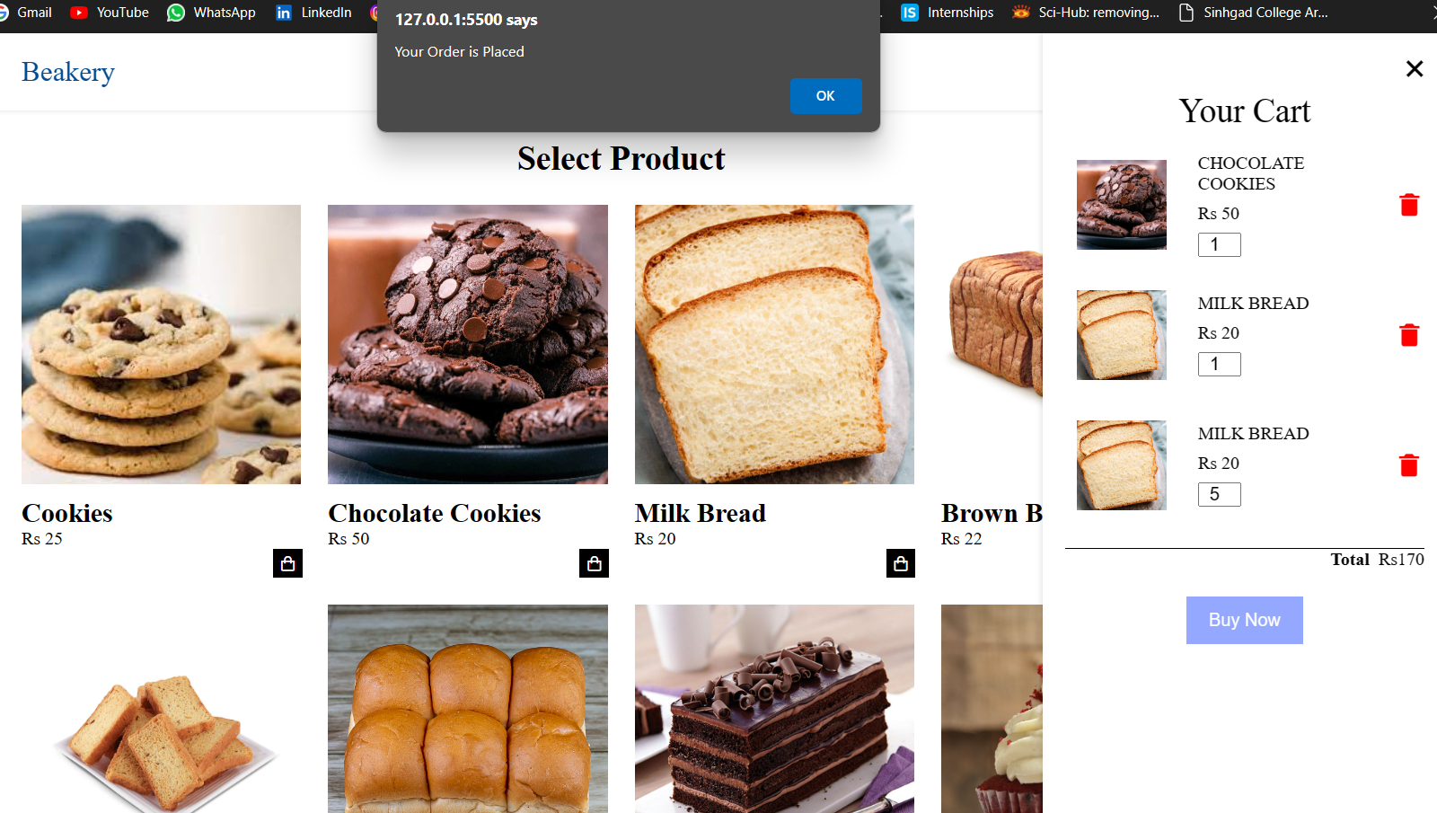

**Sample Code**

**HTML Code: -**

<!DOCTYPE html>

<html lang="en">

<head>

<meta charset="UTF-8">

<meta http-equiv="X-UA-Compatible" content="IE=edge">

<meta name="viewport" content="width=device-width, initial-scale=1.0">

<title>Welcome</title>

<link rel="stylesheet" href="style.css">

<link href='https://unpkg.com/boxicons@2.1.4/css/boxicons.min.css' rel='stylesheet'>

</head>

<body>

<header>

<div class="bar container">

<!-- <p class="brand_name">Bakery Unit</p> -->

<a href="#" class="brand_name">Beakery</a>

<i class='bx bx-shopping-bag' id="shopping_icon"></i>

<div class="cart">

<h2 class="cart_title">Your Cart</h2>

<div class="cart_content">

</div>

<!--Total-->

<div class="total">

<div class="total-title">Total</div>

<div class="total-price">Rs0</div>

</div>

<!-- Buy Button-->

<button type="button" class="btn-buy">Buy Now</button>

<!--Cart Close-->

<i class='bx bx-x' id="close-cart"></i>

</div>

</div>

</header>

<section class="product container">

<h2 class="product_titale">Select Product</h2>

<div class="product_content">

<div class="product_box">

<img src="/Project_Related_IMG/cookies.jpg" alt="" class="product_img">

<h2 class="product_name">Cookies</h2>

<span class="product_price">Rs 25</span>

<i class='bx bx-shopping-bag add-cart'></i>

</div>

<div class="product_box">

<img src="/Project_Related_IMG/chocolate-cookies.jpg" alt="" class="product_img">

<h2 class="product_name">Chocolate Cookies</h2>

<span class="product_price">Rs 50</span>

<i class='bx bx-shopping-bag add-cart'></i>

</div>

<div class="product_box">

<img src="/Project_Related_IMG/milk-bread.jpg" alt="" class="product_img">

<h2 class="product_name">Milk Bread</h2>

<span class="product_price">Rs 20</span>

<i class='bx bx-shopping-bag add-cart'></i>

</div>

<div class="product_box">

<img src="/Project_Related_IMG/brown-bread.jpg" alt="" class="product_img">

<h2 class="product_name">Brown Bread</h2>

<span class="product_price">Rs 22</span>

<i class='bx bx-shopping-bag add-cart'></i>

</div>

<div class="product_box">

<img src="/Project_Related_IMG/toast.jpeg" alt="" class="product_img">

<h2 class="product_name">Totast</h2>

<span class="product_price">Rs 25</span>

<i class='bx bx-shopping-bag add-cart'></i>

</div>

<div class="product_box">

<img src="/Project_Related_IMG/pav.jpg" alt="" class="product_img">

<h2 class="product_name">Pav</h2>

<span class="product_price">Rs 14</span>

<i class='bx bx-shopping-bag add-cart'></i>

</div>

<div class="product_box">

<img src="/Project_Related_IMG/pastry.jpg" alt="" class="product_img">

<h2 class="product_name">Pastry</h2>

<span class="product_price">Rs 30</span>

<i class='bx bx-shopping-bag add-cart'></i>

</div>

<div class="product_box">

<img src="/Project_Related_IMG/cup_cake.jpg" alt="" class="product_img">

<h2 class="product_name">Cup Cake</h2>

<span class="product_price">Rs 15</span>

<i class='bx bx-shopping-bag add-cart'></i>

</div>

</div>

</section>

<script src="script.js"></script>

</body>

</html>

**CSS Code: -**

*{

margin: 0;

padding: 0;

scroll-padding-top: 2rem;

scroll-behavior: smooth;

box-sizing: border-box;

list-style: none;

text-decoration: none;

}

img{

width: 100%;

}

section{

padding: 4rem 0 3rem;

}

.container{

max-width: 1068px;

margin: auto;

width: 100%;

}

header{

position: fixed;

top: 0;

left: 0;

width: 100%;

background-color: white;

box-shadow: 0 1px 4px hsl(0 4% 15% / 10%);

z-index: 100;

}

.bar{

display: flex;

align-items: center;

justify-content: space-between;

padding: 20px 0;

}

.brand_name{

font-size: 25px;

font-weight: 300;

}

#shopping_icon{

font-size: 1.8rem;

cursor: pointer;

}

.cart{

position: fixed;

top: 0;

right: -100%;

width: 360px;

min-height: 100vh;

padding: 20px;

background-color: white;

box-shadow: -2px 0 4px hsl(0 4% 15% / 10%);

transition: 0.3s;

}

.cart.active{

right: 0;

}

.cart_title{

text-align: center;

font-size: 30px;

font-weight: 500;

margin-top: 2rem;

}

.cart_box{

display: grid;

grid-template-columns: 32% 50% 18%;

align-items: center;

gap: 1rem;

margin-top: 1rem;

}

.cart_img{

width: 100px;

height: 100px;

object-fit: contain;

padding: 10px;

}

.detail_box{

display: grid;

row-gap: 0.5rem;

}

.cart_product_title{

font-size: 1rem;

text-transform: uppercase;

}

.cart_price{

font-weight: 500;

}

.cart_quantity{

/* border: 1px solid red; */

/* outline-color: red; */

width: 2.4rem;

text-align: center;

font-size: 1rem;

}

.cart-remove{

font-size: 24px;

color: red;

cursor: pointer;

}

.total{

display: flex;

justify-content: flex-end;

margin-top: 1.5rem;

border-top: 1px solid black;

}

.total-title{

font-size: 1rem;

font-weight: 600;

}

.total-price{

margin-left: 0.5rem;

}

.btn-buy{

display: flex;

margin: 1.5rem auto 0 auto;

padding: 12px 20px;

border: none;

background: rgba(0, 47, 255, 0.418);

color: white;

font-size: 1rem;

font-weight: 500;

cursor: pointer;

}

#close-cart{

position: absolute;

top: 1rem;

right: 0.8rem;

font-size: 2rem;

cursor: pointer;

}

.product_titale{

font-size: 30px;

font-weight: 600;

text-align: center;

margin-bottom: 1.5rem;

}

.product{

margin-top: 30px;

}

.product_content{

display: grid;

grid-template-columns: repeat(auto-fit, minmax(220px, auto));

gap: 1.5rem;

}

.product_box{

position: relative;

}

.product_box:hover{

padding: 10px;

border: 1px solid grey;

border-radius: 10px;

transition: 0.4s;

}

.product_img{

width: 100%;

height: auto;

margin-bottom: 0.5rem;

}

.add-cart{

margin-left: 90%;

background-color: black;

color: white;

padding: 5px;

cursor: pointer;

}

**JavaScript Code: -**

let shopping_icon = document.querySelector("#shopping_icon");

let cart = document.querySelector(".cart");

let closeCart = document.querySelector("#close-cart");

shopping_icon.onclick = () => {

cart.classList.add("active");

};

closeCart.onclick = () => {

cart.classList.remove("active");

};

if(document.readyState == "loding") {

document.addEventListener("DOMContentLoaded", ready);

} else {

ready();

}

function ready() {

var removeCartButtons = document.getElementsByClassName("cart-remove");

console.log(removeCartButtons);

for(var i=0; i<removeCartButtons.length; i++) {

var button = removeCartButtons[i];

button.addEventListener("click", removeCartItem);

}

//Quantity Changes Code

var quantityInputs = document.getElementsByClassName("cart_quantity");

for(var i=0; i < quantityInputs.length; i++){

var input = quantityInputs[i];

input.addEventListener("change", quantityChanged);

}

// Add Item in Cart Code

var addCart = document.getElementsByClassName("add-cart");

for(var i = 0; i < addCart.length; i++){

var button = addCart[i];

button.addEventListener("click", addCartClicked);

}

//Buy Button Work

document.getElementsByClassName("btn-buy")[0].addEventListener("click", buyButtonClicked);

}

function buyButtonClicked(){

alert("Your Order is Placed");

var cartContent = document.getElementsByClassName("cart_content")[0];

while(cartContent.hasChildNodes()){

cartContent.removeChild(cartContent.firstChild);

}

updatetotal();

}

// Remove Item From Cart Code

function removeCartItem(event) {

var buttonClicked = event.target;

buttonClicked.parentElement.remove();

updatetotal();

}

//Quantity Changes with price

function quantityChanged(event){

var input = event.target;

if(isNaN(input.value) || input.value <= 0){

input.value = 1;

}

updatetotal();

}

// Add To Cart

function addCartClicked(event){

var button = event.target;

var shopProduct = button.parentElement;

var title = shopProduct.getElementsByClassName("product_name")[0].innerText;

var price = shopProduct.getElementsByClassName("product_price")[0].innerText;

var productImg = shopProduct.getElementsByClassName("product_img")[0].src;

addProductToCart(title, price, productImg);

updatetotal();

}

function addProductToCart(title, price, productImg){

var cartShopBox = document.createElement("div");

cartShopBox.classList.add("cart_box");

var cartItems = document.getElementsByClassName("cart_content")[0];

var cartItemsNames = cartItems.getElementsByClassName("cart_product_title");

for(var i =0; i < cartItemsNames.length; i++){

if (cartItemsNames[i].innerText == title){

alert("You have Already add this item into cart");

return;

}

}

var cartBoxContent = `

<img src="${productImg}" alt="" class="cart_img">

<div class="detail_box">

<div class="cart_product_title">${title}</div>

<div class="cart_price">${price}</div>

<input type="number" value="1" class="cart_quantity">

</div>

<!--Remove Cart-->

<i class='bx bxs-trash-alt cart-remove'></i>`;

cartShopBox.innerHTML = cartBoxContent;

cartItems.append(cartShopBox);

cartShopBox.getElementsByClassName("cart-remove")[0].addEventListener("click", removeCartItem);

cartShopBox.getElementsByClassName("cart_quantity")[0].addEventListener("change", quantityChanged);

}

// Update Total Price Code

function updatetotal(){

var cartContent = document.getElementsByClassName("cart_content")[0];

var cartBoxes = cartContent.getElementsByClassName("cart_box");

var total = 0;

for(var i = 0; i < cartBoxes.length; i++){

var cartBox = cartBoxes[i];

var priceElement = cartBox.getElementsByClassName("cart_price")[0];

var quantityElement = cartBox.getElementsByClassName("cart_quantity")[0];

var price = parseFloat(priceElement.innerHTML.replace("Rs", ""));

var quantity = quantityElement.value;

total = total + price * quantity;

}

document.getElementsByClassName("total-price")[0].innerText = "Rs" + total;

}

**Future Enhancement**

Single page websites can be an effective way to show a product, service, or portfolio in a concise and visually appealing way. However, there are some potential limitations to this approach, such as limited content and difficulty in optimizing for search engines. Here are some potential future enhancements for single page websites:

* Improved navigation
* Dynamic content
* Better search engine optimization (SEO)
* Integration with other platforms

**Limitations**

* Limited space: Single page websites have limited space to present all of the products and services offered by an e-commerce store. This can lead to a lack of detailed product descriptions, which can result in decreased sales.
* Slow page loading times: Single page websites can be slower to load due to the large amount of content on a single page. This can lead to a poor user experience and cause potential customers to leave the site.
* Limited scalability: Single page websites can be limited in their ability to scale as the business grows. As more products or services are added, the single page can become cluttered and difficult to navigate, leading to decreased sales and customer satisfaction.

**Bibliography**

**Books**

1. JavaScript Enlightenment, Cody Lindley-First Edition, based on JavaScript 1.5, ECMA-262, Edition
2. Complete CSS Guide, Maxine Sherrin and John Allsopp-O'Reilly Media; September 2012

**Websites**

1. http://www.w3schools.com/html/defualt.asp
2. http://www.w3schools.com/css/default.asp
3. http://www.w3schools.com/js/default.asp